**GUIDE FOR SUPPLIERREGISTRATION ON UMUCYO**

1. **BACKGROUND**

The Government of Rwanda decided to establish an electronic public procurement system (e-Procurement System). All public procurement transactions are set to be conducted electronically. These include: (i) registration of government suppliers, (ii) preparation and publication of procurement plans, (iii) Submission and opening of bids (iv) Selections and notification of winners, (v) negotiation and signing of contracts,(vi) submission of goods delivery notes and transmission of goods inspection and acceptance report, to mention a few. In addition, there will be an electronic catalogue (database of goods and services) and electronic shopping mall that will be new components in public procurement system.

The system has kicked off its pilot phase in July 2016, with 9 pilot entities namely; MINECOFIN, MININFRA, MINISANTE, Gasabo District, Kicukiro District, RDB, RTDA, RBC.

All users, procuring entities staff, suppliers, auditors, RPPA and others are required to be registered on Umucyo system before they can use it. This guide serves as a simplified tool to guide suppliers in the registration process.

1. STEPS OF REGISTRATION

The registration on Umucyo system is divided in two steps:

1. Registration of corporate Organization/Company/Individual Consultants
2. Registration of users

**NOTE 1:**

Umucyo system identifies users by their Digital certificates (Digital Identity), this certificate is issued by Rwanda Development Board, in its PKI Division. Check the requirement on <http://govca.rw/eng/customer/notification.php>, download appropriate form on <http://govca.rw/eng/service/application.php> .

Local companies should physically visit the PKI office at Telecom House, Boulevard de l’Umuganda, KG 498 St Kacyiru Kigali, 1st Floor, Kacyiru.

**Foreign companies should send their applications to** [pki@rdb.rw](mailto:pki@rdb.rw).

Guide for Certificate issuing can be accessed from:

<http://govca.rw/eng/Certificate%20issuing%20guideline1.pdf>

Once you have obtained the digital certificate, you can register into Umucyo System.

1. **COMPANY REGISTRATION**

First visit [www.umucyo.gov.rw](http://www.umucyo.gov.rw) and select “Supplier Reg.”

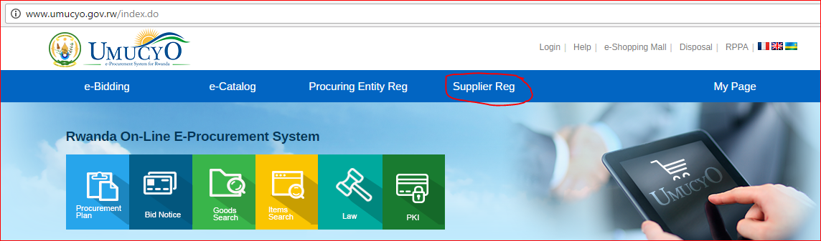

Download Java and EXE from Umucyo system and installed them on your computer. Java should be downloaded and installed first and then EXE.

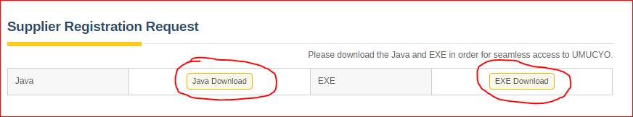

Fill your TIN Number in the appropriate field and click “Search”

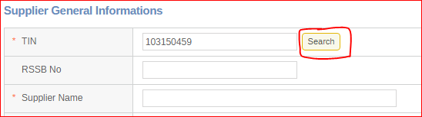

Select the location where your Digital Certificate is stored(your machine, USB or any other device), select, put your password and confirm:

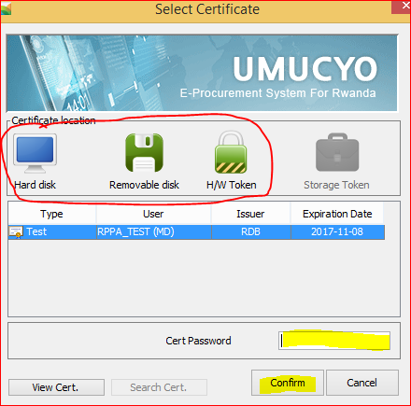

**Results:**

Through the external linkage with RDB, registration data related to the TIN Number will come automatically.

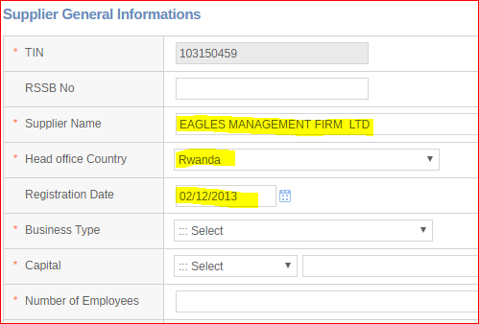

Business activities will also come automatically:

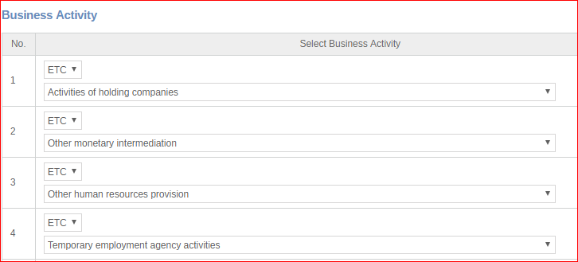

**Fill the rest of information with a careful attention to mandatory fields marked with \***

**NOTE:**

For foreign bidders and local individual consultants, as their TIN Numbers are not registered in RDB there will not be automatic data filled in. they will fill manually all data fields.

Agree to the terms and conditions by selecting “Agree” and click “save” and confirm.

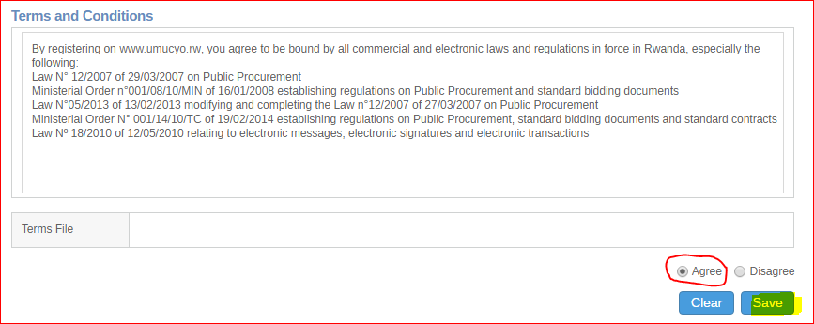

At his stage, your application will be submitted to the “Supplier Approval Administrator” in Rwanda Public Procurement Authority. After Approval/Rejection, you will receive notification on your registered email.

**You can also check your application status**

Click on “Supplier Reg.” and see “Application status”

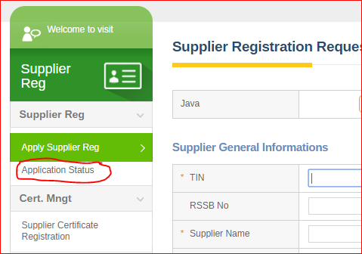

Fill your TIN Number and click “Search”,

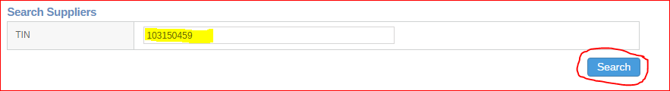

After you confirm with your password, view “Progress status” and “comment”

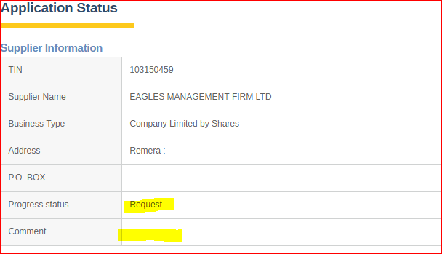

If your application is rejected, you correct or fulfill the required changes and apply again.

If your application is approved, you will move to the second step: **Certificate registration.**

1. **SUPPLIER CERTIFICATE REGISTRATION**

Click on “**Supplier Reg**.” and see and click “**Supplier Certificate Registration**”. Fill your TIN Number and click “**Search**”

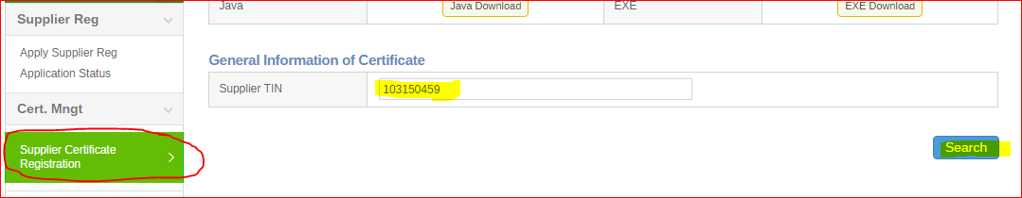

After you confirm with your password, click on “**New Registration of Certification**”

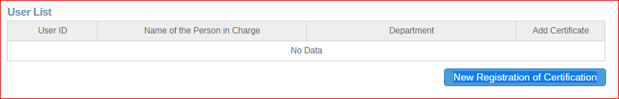

Fill the table with User Information. This information is the one contained on the digital certificate of the user. Pay a special attention to mandatory fields marked with **\***

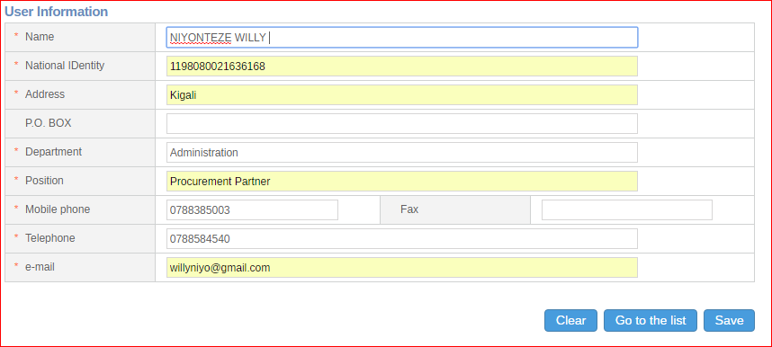

Click Save, then confirm with you password and your certificate is successfully registered!

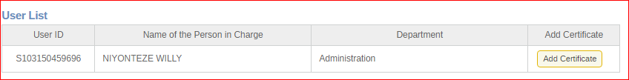

NOW YOU ARE A MEMBER OF UMUCYO!

**You can log in as member**

Click “Log in”

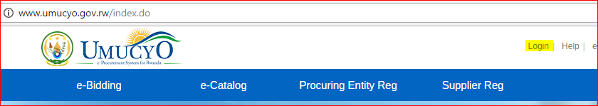

Login as “Member” by clicking the appropriate Login and confirm with password

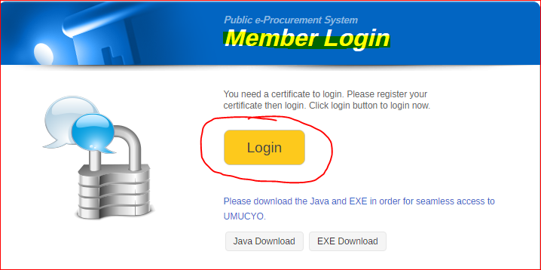

You are now logged in and enjoy all your rights as Member

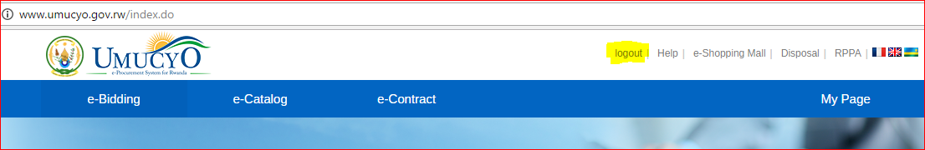

**What next?**

Now you are a member, for further skills refer to other guides published on umucyo system, main page, under “Admin Announcement “.

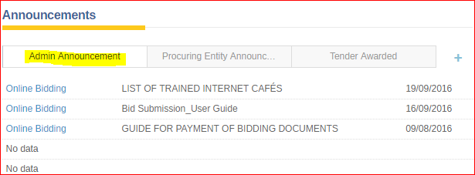

**Contacts**

**For any other assistance please contact us at:**

The Rwanda Public Procurement Authority  
Plot No.2, KN 3 AV   
12th FLOOR, GRAND PENSION PLAZA  
P. O .Box: 4276 KIGALI/RWANDA  
E-mail: [e-procurement@minecofin.gov.rw](mailto:e-procurement@minecofin.gov.rw)   
[www.umucyo.gov.rw](http://www.umucyo.gov.rw)   
Toll free: 3131 (+250788381536 for international calls)